Pupil premium strategy statement – Kingskerswell Church of England Primary School

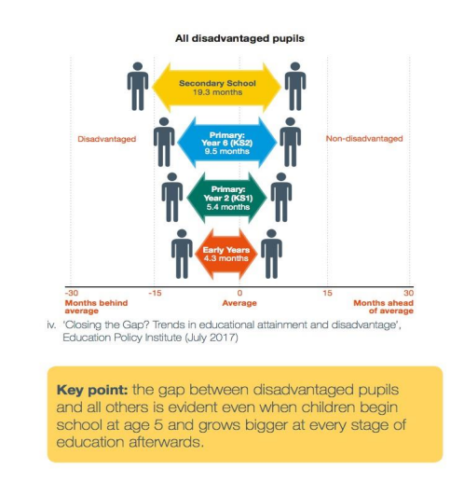
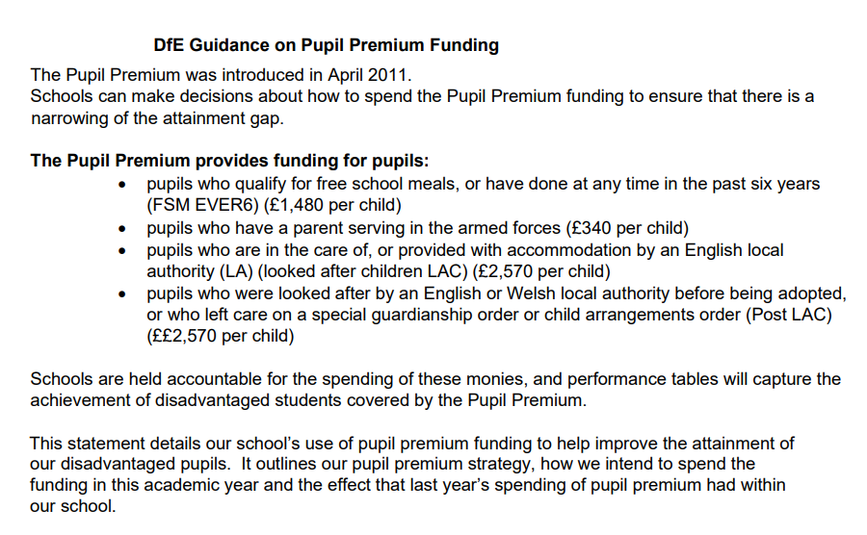

This statement details our school’s use of pupil premium funding to help improve the attainment of our disadvantaged pupils.
It outlines our pupil premium strategy, how we intend to spend the funding in this academic year and the outcomes for disadvantaged pupils last academic year.

School overview
Detail | Data
Number of pupils in school | 356
Proportion (%) of pupil premium eligible pupils | 16%
Academic year/years that our current pupil premium strategy plan covers (3-year plans are recommended – you must still publish an updated statement each academic year) | 2025-27
Date this statement was published | September 25
Date on which it will be reviewed | September 26
Statement authorised by | Susan Robinson
Pupil premium lead | Karen Strachan
Governor / Trustee lead | Susan Robinson

Funding overview
Detail | Amount
Pupil premium funding allocation this academic year | £103,335
Pupil premium funding carried forward from previous years (enter £0 if not applicable) | £0
Total budget for this academic year  If your school is an academy in a trust that pools this funding, state the amount available to your school this academic year | £103,335

Part A: Pupil premium strategy plan

Statement of intent
Context and Vision
At Kingskerswell C of E Primary |School, our mission is to nurture every child’s potential through a culture rooted in our core values: Resilience, Community, Respect, Forgiveness, Trust, Love, and Friendship. We are committed to ensuring that all pupils, especially those eligible for Pupil Premium funding, are supported to thrive academically, socially, and emotionally.
We believe that disadvantage should never be a barrier to success. Our strategy is driven by a deep sense of community and trust, where every child is valued and supported. We aim to foster resilience in our learners, encouraging them to persevere through challenges, and to build strong relationships based on respect, love, and friendship. Through a compassionate and inclusive approach, we also promote forgiveness, helping pupils learn from setbacks and grow with confidence.
Barriers to Learning
We recognise that disadvantaged pupils may face a range of barriers that impact their learning and wellbeing. These include:
Gaps in prior learning due to disrupted education or limited access to enrichment.
Social and emotional needs, including low self-confidence, anxiety, or trauma.
Attendance and punctuality concerns, which affect continuity and progress.
Limited parental engagement or access to learning resources at home.
Language and communication difficulties, particularly for pupils with EAL or speech and language needs.
Our strategy is designed to be responsive and personalised, recognising that each child’s experience is unique.
Strategic Priorities
To overcome these barriers and uphold our values, our strategic priorities are:
Delivering high-quality teaching for all
We invest in professional development and evidence-based practice to ensure that every pupil receives excellent teaching. This supports resilience and builds trust in the learning process.
Providing targeted academic support
Through small group interventions, tutoring, and personalised plans, we aim to close attainment gaps and promote respect for each learner’s journey.
Supporting social and emotional development
We embed pastoral care, mentoring, and access to mental health services to help pupils develop love, friendship, and forgiveness in their relationships and self-image.
Improving attendance and engagement
We work closely with families and external agencies to reduce absence and promote a sense of community and belonging.
Expanding enrichment and cultural capital
We ensure all pupils have access to extracurricular activities and experiences that broaden horizons and raise aspirations, reinforcing respect, trust, and resilience.
Our approach is underpinned by ongoing evaluation to ensure that interventions are impactful, and resources are used effectively.

Challenges
This details the key challenges to achievement that we have identified among our disadvantaged pupils.
Challenge number | Detail of challenge
1 | Assessments, observations, and discussions with pupils indicate underdeveloped oral language skills and vocabulary gaps among many disadvantaged pupils. These are evident from Reception through to KS2 and in general, are more prevalent among our disadvantaged pupils than their peers
2 | Assessments, observations, and discussions with pupils suggest disadvantaged pupils generally have greater difficulties with phonics than their peers. This negatively impacts their development as readers. Needs continue after fluency due to limited vocabulary and experience of some pupils
3 | Formal and informal assessments indicate that a mastery curriculum in Mathematics (White Rose Maths) is less accessible for lower attainers, and particularly our disadvantaged pupils.
4 | Writing assessments indicates that PP boys are lower attaining than girls.
5 | Our assessments (emotional wellbeing profiling, Cpoms), observations and discussions with pupils and families have identified, increased social and emotional need in pupils and their parents. These challenges often affect disadvantaged children including their attainment.
6 | 29% of pupil premium children are also on the SEND register. 6% of the non-pupil premium are SEND.
7 | Analysis of 2024-25 data shows that children living in disadvantage, attend less well than their peers. 10 % of PP children are persistently absent compared to 0.7% non-pupil premium.

Intended outcomes
This explains the outcomes we are aiming for by the end of our current strategy plan, and how we will measure whether they have been achieved.
Intended outcome | Success criteria
Challenge 1 - Attendance for disadvantaged pupils in line with all pupils. | Data shows that attendance of pupils eligible for the Pupil Premium is in line with this group nationally and locally. Those PP children that are persistent absentees are monitored and reviewed daily. First day phone calls. Attendance meetings and letters to parents.
Challenge 2 - Provide and embed a bespoke curriculum including a wide range of enrichment opportunities to broaden experiences and aspirations of all children including those eligible for PP. | Increased offer of and participation in enrichment activities, particularly among disadvantaged pupils, such as after school clubs, residentials, wraparound care, Forest School and educational visits.  Focus on emotional wellbeing and pastoral support. Use of Boxhall assessment as a baseline for targeted support
Challenge 3 – Raising aspirations and expectations for parents to recognise that their children can achieve, be successful and thrive as well as any other pupils. | Supporting parents with attendance and recognising the value of school in raising aspirations. Ensuring family participate in school events and support their children in attending clubs and events in school. Providing access to wraparound care to support vulnerable families.
Challenge 4 - Improved oral language skills and vocabulary among disadvantaged pupils. | Assessments and observations indicate significantly improved oral language among disadvantaged pupils. This is evident when triangulated with other sources of evidence, including engagement in lessons, book scrutiny and ongoing formative assessment. NELI, Language Link and Speech Link provide further assessment data and scaled score. Reduced referrals to Communication and Interaction and Speech and Language professionals
Challenge 5 - Improved phonics, writing and maths attainment among disadvantaged pupils. | Termly progress and attainment monitoring shows diminishing difference between disadvantaged pupils and their peers. GLD, Phonics, KS1 and KS2 end of year data shows diminished difference from 2024 - 25. Greater percentage of children off-scheme by end of autumn term, Year 2. White Rose intervention programme demonstrates impact progress of PP children. English leader monitoring of PP boys throughout the school.
Challenge 6 - Success for pupils with SEND | Learning plans updated termly and monitored by SENDCO. Meeting with parents of children with learning plans. Provision maps. Quality first teaching, pre-teach. Interventions. Freckles, homework club, RWI one to one,

Activity in this academic year
This details how we intend to spend our pupil premium funding this academic year to address the challenges listed above.

Teaching (for example, CPD, recruitment and retention)
Budgeted cost: £ 28,000
Activity | Evidence that supports this approach | Challenge number(s) addressed
Quality First teaching | ‘The best available evidence indicates that great teaching is the most important lever schools have to improve outcomes for children.’ EEF | 1-6
All teachers and teaching assistants receive high quality CPD, including at twilight sessions – in-line with key school improvement priorities. | Staff meeting timetable details CPD provided throughout the year for teachers as well as whole staff. Support includes support for classroom interventions, curriculum, SEND support and focused on the school improvement focus of writing. | 2,4,5
Phonics Lead – Embed RWI phonics programme. Training for support staff. Resources and CPD for all Reception – Y6 staff, RWI reading material for Reception – Y6, AR reading books for those pupils who are free readers. | Phonics approaches have a strong evidence base that indicates a positive impact on the accuracy of word reading (though not necessarily comprehension), particularly for disadvantaged pupils:  https://educationendowmentfoundation.org.uk/education-evidence/teaching-learning-toolkit/phonics  - Phonics instruction (+5months High impact vs very low cost) | 2-4
Targeted support for pupil premium children both in class and in Forest School. | Forest School led sessions for all children with particular focus on PP.  3 days – LA  2 days – TS  2 days - FM | 5

Targeted academic support (for example, tutoring, one-to-one support, structured interventions)
Budgeted cost: £ 65,000
Activity | Evidence that supports this approach | Challenge number(s) addressed
White Rose intervention programme implemented for bottom 20% of learners. | The EEF toolkit suggests that mastery learning accelerates progress. Work is challenging and is particularly effective when pupils work in groups and take responsibility for supporting each other’s progress: https://educationendowmentfoundation.org.uk/educationevidence/teaching-learning-toolkit/collaborative-learningapproaches  https://educationendowmentfoundation.org.uk/educationevidence/guidance-reports/early-maths Improving Mathematics in Key Stages 2 and 3
Targeted intervention for PP children, including TA support and access to Freckle learning support for maths. | £4000 - Freckle subscription for all pupils – targeted support based on prior assessment. Homework set weekly using Freckle to target specific objectives. Homework club provided for PP children, supervised by teachers.  £10,000 – Flexible TA support to work with PP and non-PP to support learning in groups or one to one.
One to one support for PP children with high needs and targeted support. | “Ensuring an effective teacher is in front of every class, and that every teacher is supported to keep improving, is the key ingredient of a successful school and should rightly be a top priority for pupil premium spending.”- EEF  Current interventions in place, based on evidence from EEF:  - Phonics instruction (+5months High impact vs very low cost)  - Oral Language interventions (+6months)  - Teaching Assistant interventions (+4months)  - Reading Comprehension strategies (reading recovery) (+6months)  Support provided for children with additional needs:  3 days support for SW  5 days support for VB  2 days - RWI  2 days - NELI speech intervention | 5

Wider strategies (for example, related to attendance, behaviour, wellbeing)
Budgeted cost: £ 9060
Activity | Evidence that supports this approach | Challenge number(s) addressed
Access to high quality experiences such as residentials and school trips. | EEF – collaborative learning (+5months)  Year 6 – Residential 2025 – 15 PP children - £2550 paid by school.  Year 4 – Residential 2025 – 13 PP children - £1210  Every year group – 2 trips x £5 each = £300  (£4060) | 3
Access to high quality after school clubs and wraparound care. | £8.50 for after school club 3:30-5:50  £3.50 for breakfast club 7:30-8:30  £5000 allocated to support PP children to access wraparound care | 3

Total budgeted cost: £ 102,060
Part B: Review of the previous academic year

Outcomes for disadvantaged pupils
Performance of disadvantaged pupils in 2024/25:

Early Years Foundation Stage:
Percentage of PP children who achieved GLD at the end of EYFS
Reading 67%, Writing 67%, Maths 67%
Whole cohort 86%
National 69%

Key Stage 1
Percentage of PP children who achieved ARE or above in RWM combined at the end of KS1
RWM 41%
Whole cohort 67%
National 59%

Key Stage 2
Percentage of PP children who achieved ARE or above in RWM combined at the end of KS2
RWM 58%
Whole Cohort 70%
National 62%

Phonics Screening
Percentage of PP pupils who passed phonics screening in Year 1
Year 1 - 53%
Whole cohort 77%
National 80%
No Year 2 PP children re-sat the phonics check in Year 2

Review
PP outcomes in statutory testing in EYFS and KS2 were in line with outcomes for all pupils nationally and above PP children nationally
PP outcomes in statutory testing in PSC (y1) and KS1 (RWM) were below their peers and below all pupils nationally

Externally provided programmes
Please include the names of any non-DfE programmes that you used your pupil premium to fund in the previous academic year.
Programme | Provider
Exeter City Football Club – Clubs and CPD | Exeter City
Freckle maths online
Times Tables Rockstars
Accelerated Reader
Read Write Inc phonics
Speech Link
Master the Curriculum
Coding package Discovery Education 9
NATRE
Letterjoin
Rockalingua
Get Set 4 Music/PE
Perihepatic music lessons – Piano and guitar | Blossom Music  Independent musician

