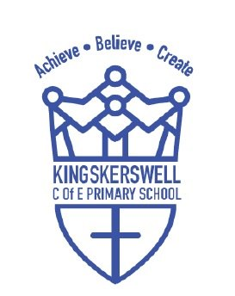

Music Development Plan
Autumn 2024- Autumn 2025
Subject Lead: Katy Mackintosh Local Music Hub: Newton Abbot, Devon
This document has been created to show how KKPS will deliver high quality music provision in curriculum music, co-curricular music and musical experiences, taking into account the key features in the national plan for music education.

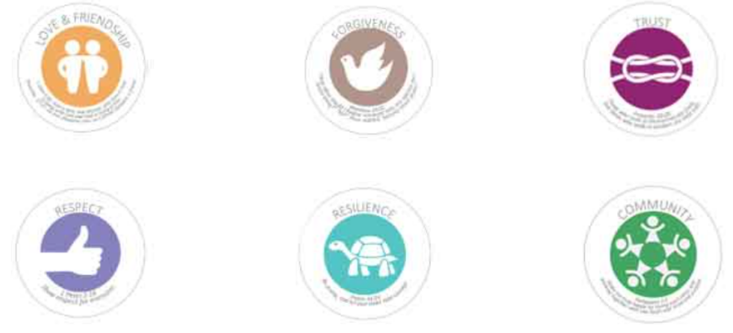
Contents
Section One: Statement of intent for Music at Kingskerswell
Section Two: Music Key Priorities (Implementation)
Section Three: Development Planning (Implementation)
Section Four: Monitoring (Impact)

Our six core Christian values of Love & Friendship, Forgiveness, Trust, Respect, Resilience, and Community support the Christian Distinctiveness at our school. Our values are firmly embedded in all we do – from the way we learn together, the way we treat ourselves and others, the way in which our curriculum develops prosperous adults of the future, and in celebrating our talents and achievements as a church community.
Our vision, Achieve, Believe and Create Together, has grown from a unified response to what we believe we are here to do, passionately echoing the vision of the Church of England’s vision for Education, to ‘live life in all its fullness’. Our vision is firmly rooted in scripture and informs the life of our school and our church community.
Every half-term, a core value is introduced during Collective Worship. ‘Windows, Mirrors and Doors’, designed by Liz Mills, is a powerful tool used to develop personal reflection and social action. Opportunities are created for our children to develop a robust knowledge of key Bible stories that teach the values, as well as stories from other world faiths and views, cultures, and non-religious stories that focus on Spiritual, Moral, Social and Cultural (SMSC) development.
Our curriculum provides real-life opportunities for our children to develop character by a taking a led on social action that is driven by what they believe in.

Section One: Statement of Intent for Music at Kingskerswell

At Kingskerswell C of E Primary School, our Music curriculum intends to:

• Foster pupils’ sensitivity to, and their understanding and enjoyment of, music, through an active involvement in listening, performing, composing and appraising;
• Enable all pupils to realise their individual creative potential and to express themselves through music;
• Enable pupils to acquire and develop the musical skills involved in performing, composing, listening and appraising;
• Extend and develop pupils’ awareness and understanding of traditions, idioms and music styles from a variety of cultures, times and places;
• Enable pupils to experience fulfilment, which derives from striving for the highest possible artistic and technical standards within any style of musical expression;
• Develop, through music, pupils’ skills which contribute to learning across the curriculum; • contribute to the community and the school’s ethos.

Section Two: Music Key Priorities

Key Priorities
To enhance the quality of music education for children across all year groups. | To ensure that the music curriculum is diverse, inclusive and reflective of different musical traditions and styles.
 | To provide ongoing professional development for teachers to stay updated on best practices and innovative techniques.
 | To ensure that all schools have access to quality instruments, music technology, and learning materials.
To foster music leadership to guarantee that every year group benefits from at least a good quality of education. | To conduct regular reviews of teaching quality in music, ensuring consistent and good delivery across all year groups.
 | To establish a strong shared vision for music education.
 | To assist staff in utilising data from teacher assessments to guide future planning, address misconceptions from pupils’ learning, and accelerate progress.
To create links with the wider curriculum, providing music-related enrichment opportunities for pupils. | To develop projects that integrate music with other subjects, such as History or Science to show the interconnectedness of learning.
 | To organise after school clubs, performances and workshops that allow pupils to explore music in creative and informal settings.

Section Three: Development Planning

Key Priority 1: To enhance the quality of music education for children across all year groups. | Lead: Katy Mackintosh | RAG
Key Priority: Quality of Teaching  - To ensure that the music curriculum is diverse, inclusive and reflective of different musical traditions and styles.  - To provide ongoing professional development for teachers to stay updated on best practices and innovative techniques.  - To ensure that all schools have access to quality instruments, music technology, and learning materials. |  | Behind  Not Achieved  Underway  Completed
Outcome – What?  What are we aiming to achieve? | Actions – How?  What will happen to achieve the outcome? | Who/when? | Resources / Costs | Success Criteria and Evaluation  What will we see when we have achieved the outcome?
To consider new scheme Get Set 4 Music to boost teacher skills and confidence. Scheme to include individual lesson plans, assessment and curriculum mapping.  To continue to loan instruments from the hub. | PTFA to raise cost for 1-year subscription of Get Set 4 Music.  Teachers to have access to all EYFS, KS1 and KS2 areas.  Subject lead to conduct music audit and place order for after half term. | PTFA  KM  25/10/24 | £324  £0 | Teachers will be able to deliver fun and interactive lessons with more confidence, developing both teacher and pupil subject knowledge and language.  Children will have an increased experience and knowledge of how to use/play different instruments.
Teachers will have a strong understanding of what and how to deliver a good quality music lesson, following a dynamic scheme setting high expectations.  Teachers to deliver at least 1 hour a week. | Subject lead to monitor…  Are musical skills progressive?  Are the four key areas of learning covered stated in the National Curriculum?  Sing & Chant  Listen & Appraise  Learn and Perform  Create and Compose  Has planning been differentiated to accommodate all pupils? – being flexible.  Are their opportunities for pupils to receive real life experiences? | KM  Half Termly | £0 | All year groups will make good progress.  Lessons will be delivered each week confidently, adapting them accordingly to accommodate for individual needs.

Key Priority 2: To foster music leadership to guarantee that every year group benefits from at least a good quality of education. | Lead: Katy Mackintosh | RAG
Key Priority: Leadership  - To conduct regular reviews of teaching quality in music, ensuring consistent and good delivery across all year groups.  - To establish a strong shared vision for music education.  - To assist staff in utilising data from teacher assessments to guide future planning, address misconceptions from pupils’ learning, and accelerate progress. |  | Behind  Not Achieved  Underway  Completed

Outcome – What?  What are we aiming to achieve? | Actions – How?  What will happen to achieve the outcome? | Who/when? | Resources / Costs | Success Criteria and Evaluation  What will we see when we have achieved the outcome?
Subject lead to support teachers navigating and delivering the new scheme of Get Set 4 Music to ensure that all children are involved in practical sessions and are developing core skills.  Subject lead to request pupil data after each unit to support teachers and accelerate progress. | Subject lead to visit classes to observe teaching, and collate feedback from both adults and children.  Subject lead to share good practice from monitoring around teaching, assessment and questioning linked to the Music Curriculum to raise pupil outcomes.  Subject lead to discuss data with class teacher and make amendments to planning where necessary to ensure that all pupils are making good progress. | KM  Termly  KM  Half termly | £0  £0 | Quality of teaching to be at least good across the school.  Increased pupil activity in wider opportunities.  Teachers will feel supported.  All pupils will make good progress from their starting point due to the analysis of data collected.

Key Priority 3: To create links with the wider curriculum, providing music-related enrichment opportunities for pupils. | Lead: Katy Mackintosh | RAG
Key Priority: Wider Curriculum  - To develop projects that integrate music with other subjects, such as History or Science to show the interconnectedness of learning.  - To organise after school clubs, performances and workshops that allow pupils to explore music in creative and informal settings. |  | Behind  Not Achieved  Underway  Completed

Outcome – What?  What are we aiming to achieve? | Actions – How?  What will happen to achieve the outcome? | Who/when? | Resources / Costs | Success Criteria and Evaluation  What will we see when we have achieved the outcome?
To work closely with the education hub in the area to identify pupil and school needs in music education, and establish how KKPS can work with other schools to achieve this. | To attend all Newton Abbot Music Network meetings to get support, updates and information of festivals, concerts and wider opportunities. | KM  23/09/24  25/11/24 | £0  ‘Gathering Day’ TBC | 'Gathering day' for Year 4 on Tuesday 25th March 2025 at The Bushel Theatre, Coombeshead Academy to enable more children to have more musical experiences and opportunities to perform. The day would involve a singing and/or instrumental workshop, plus the opportunity for each school to share a well-rehearsed song or piece of music.
To apply for a Music Education Grant (MEG) to support delivery of the current National Plan for Music Education, particularly Whole Class Ensemble Tuition (WCET). | Apply online:  https://www.musiceducationhub.org  /site/schools/funding-opportunities/ | KM/KS  27/09/24 | £0 | Funding received can contribute towards projects, performances and workshops.  Opportunity to enjoy a live performance.
To begin a choir as instructed in the National Plan for Music Education.  There is also a huge range of physical, mental, and emotional benefits that children can gain from joining a choir. | Choir club and Drama club to be available across all year groups 3:30-4:30pm, run by various adults.  Children to have ‘band practice’ either after school or at lunchtimes as stated in the national plan for music education. | KS/DY  Teachers | £0  £0 | This could lead onto pupils taking part in broader and more challenging opportunities, including area ensembles.  - Children should feel an increased happiness, develop their self-confidence.
Pupils to receive learning opportunities to develop their talents and interests. | Ensure a range of opportunities such as music ensembles, singing assemblies, choir concerts, whole class instrumental lessons, individual music lessons…  Upload photos to school website/facebook page to increase the profile of music. | Teachers  Throughout the year | £? | Staff and parents become aware of the range and quality of music activities offered and the pupils’ musical achievements.

Section Four: Monitoring

Leaders’ Monitoring Schedule
School Development Plan Monitoring 2024/2025

Priority | Responsible Staff | Monitoring Leader | Monitoring Date
To enhance the quality of music education for children across all year groups. | Katy Mackintosh | Katy Mackintosh  Dan Yiend | Termly
To foster music leadership to guarantee that every year group benefits from at least a good quality of education. | Katy Mackintosh | Katy Mackintosh  Dan Yiend | Termly
To create links with the wider curriculum, providing music-related enrichment opportunities for pupils. | Katy Mackintosh | Katy Mackintosh  Karen Strachan | Termly

